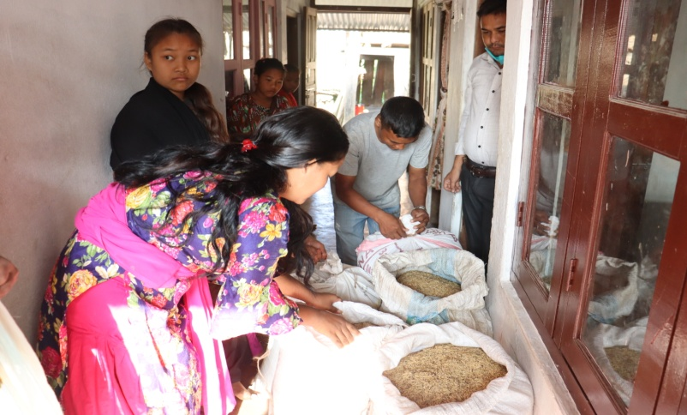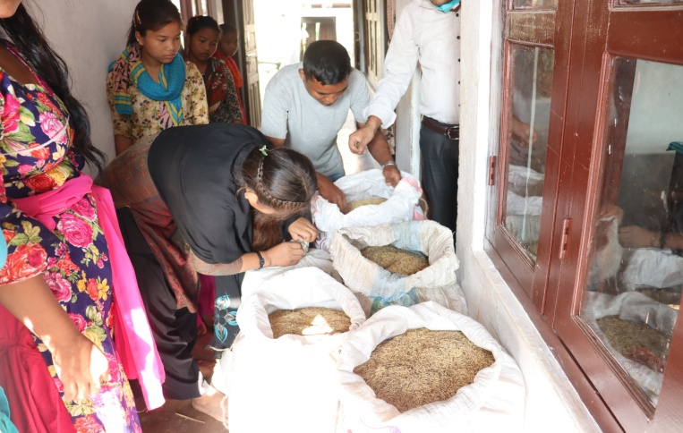

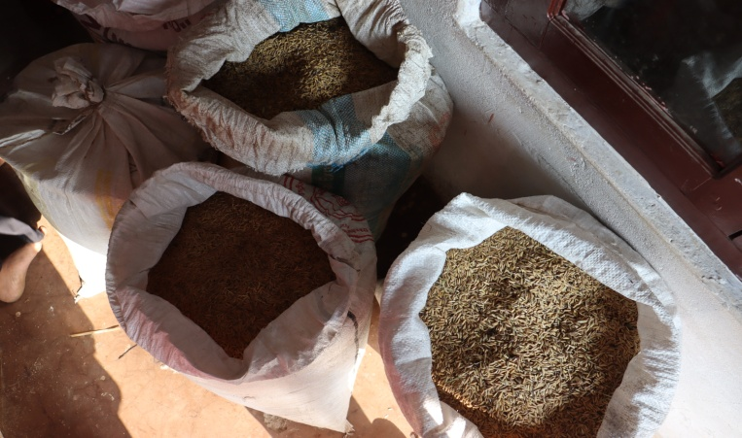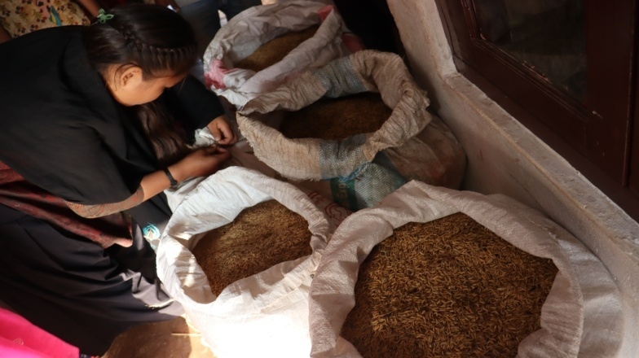

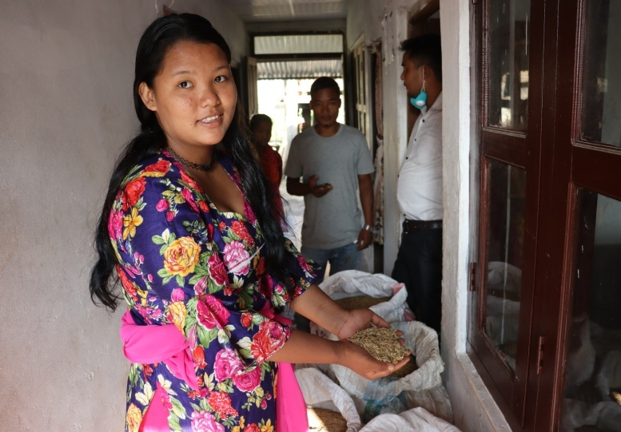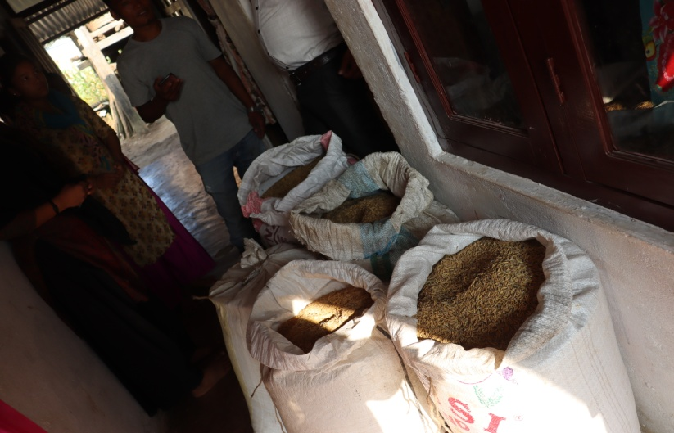

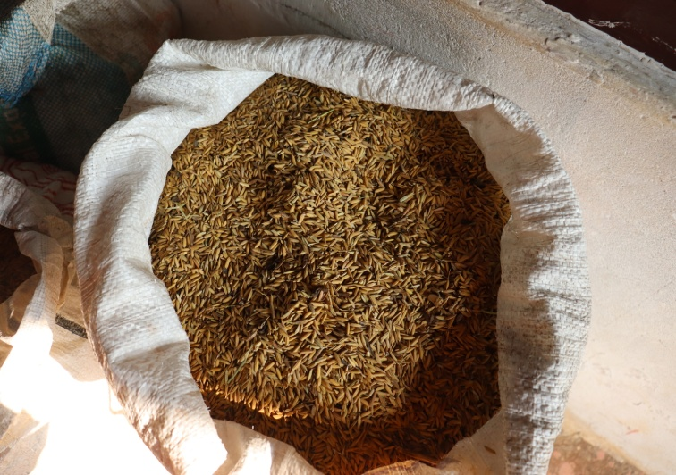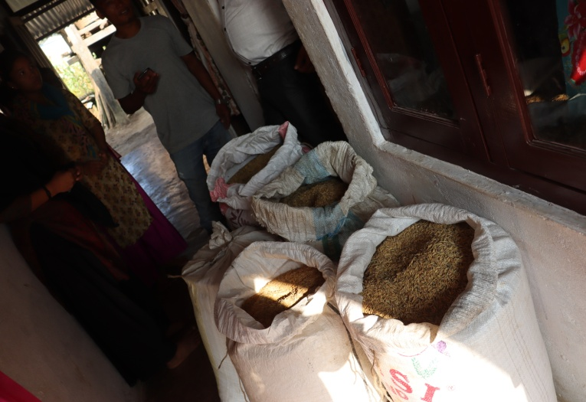

**Paddy Rice Harvest**

Brother this is paddy rice harvest in Bhalumara, we got 250 kg paddy rice from the field, and it will cover for whole month of November 2020 in this location, we don’t need to send any amount for the rice expenses.

Brother now we are planning to implant different types of vegetables like potatoes, onions, cauliflowers and green leafs etc.

Please click here to see more pictures of paddy rice

https://photos.app.goo.gl/VjcSYtbkkMYQEW2G9

Thank you

In Him

Ranjit and Lokendra